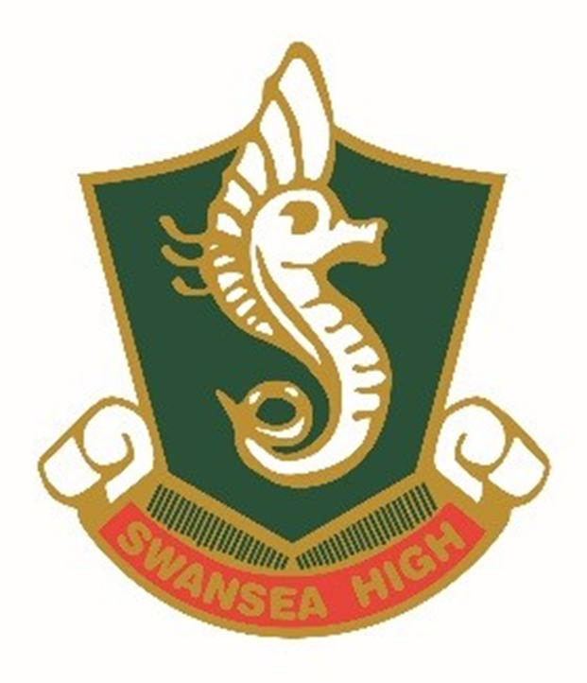
SWANSEA HIGH SCHOOL
STUDENT ASSESSMENT PROCEDURES

CONTENTS | PAGE
Rationale and Aim | 4
Student and Parent Responsibilities | 4
Effectiveness in Assessment  - Outcomes Based Assessment | 5
RoSA | 5
Assessment Schedules  - Assessment Schedule Communication | 6
Assessment Tasks  - Assessment Notice and Required Information  - Signing for Receipt of Tasks, Submission and Feedback  - Year 11 Yearly Examinations and HSC Trial Examinations  - Submission of Tasks  - Examinations and In Class Tasks  - Exam Conditions  - Non-Serious or Unsatisfactory Attempts of Assessment Tasks | 6
Illness, Misadventure and/or Appeals  - School leave  - Technical Failure  - Absence, Illness/Misadventure of Group Performances  - Students Undertaking VET Work Placement or Work Experience  - Summary of late submission procedures | 10
Illness, Misadventure and/or Appeals Procedures Years 7-10  - Procedures  - Communication Home  - Late Submission of Tasks Years 7 and 8  - Late Submission of Tasks Years 9 and 10  - Appeals | 14
Illness, Misadventure and/or Appeals Procedures Years 11 and 12  - Procedures  - Communication Home  - Late Submission of Tasks  - Appeals | 15
Students in Danger of Not Meeting Requirements  - Monitoring Satisfactory Course Completion  - Years 7 and 8 Faculty Concern Flow Chart  - Years 9 -12 ‘N Award Flow Chart | 17
Disability Provisions  - HSC and School Based Assessment Disability Provisions  - Years 7-11 Disability Provisions | 19
Malpractice  - Procedures for Malpractice in Tasks  - Procedures for Malpractice in Exams  - Appeals against Malpractice Penalties | 21
Marking and Feedback  - Awarding Marks for an Assessment Task  - Assessment Feedback for Individuals and Classes  - Stage 6 Rank Order Advice  - Awarding Grades for End of Course Performance  - Adjusting Marks for Final Grades  - Establishing Student Performance Years 7-10  - Establishing Student Performance Year 11  - Establishing Student Performance Year 12  - HSC Grades  - HSC Final Assessment Marks  - HSC Estimated Marks  - Ensuring Security of Major Works  - Accumulation of Preliminary Courses  - Invalid Tasks  - Grade Appeals to NESA | 22

Rationale and Aim
The Swansea High School Assessment Procedures Document is designed to align all faculties to ensure that assessment processes and procedures are consistent and fair across the school in order to support task completion, foster student engagement and improve student learning outcomes.

The document aims to provide consistency and fairness, for all assessment procedures, across Years 7-12 at Swansea High School.

In order to establish an effective and successful assessment program, collaborative planning practices within faculties aim to ensure that:

- outcomes are central to the decisions made about teaching, learning and assessment
- evidence about student learning directly relates to the assessed outcomes
- teachers use evidence to determine how well students are achieving in relation to the outcomes
- teacher feedback and student reflection plays an integral part of the assessment process, and
- evidence of student achievement informs future teaching and learning.

Student and Parent Responsibilities

Our aim at SHS is for all students to become responsible for their own learning. Parents/ and carers are encouraged to support their children by helping them to establish regular home study/revision routines.

Students are expected to:
- complete all assessment tasks by the due dates and times specified
- where assessment tasks involve attendance at excursions, field studies etc attendance is compulsory.
- all work submitted for assessment must be the student’s own work, see Malpractice section for further information/
- be aware of assessment task dates for all courses and to organise a study schedule accordingly.
- follow procedures for Illness/Misadventure/Appeal. Technology malfunction, including printer failure, is not an acceptable excuse for the non-submission of a task.
Effectiveness in Assessment
Outcomes Based Assessment
All schools are required to deliver programs of study that comply with the requirements of the NSW Education Standards Authority (NESA) syllabuses. More detailed information concerning each course and syllabus outcomes are available on the NESA website or via the following link:
https://www.educationstandards.nsw.edu.au
For each course taught, it is a requirement of the assessment program that schools establish a program of assessment tasks. These tasks are conducted throughout the year and each have a weighting which is used as a component of the reporting process. The weighting is a percentage which indicates the significance of the task in the overall grade for the course.
School-based assessment tasks are linked to performance descriptors (grades) because the task focuses on outcomes. They are valid instruments for what they are designed to assess, and the marking guidelines relate to the outcomes and the NESA performance standards.
The assessment program at SHS incorporates the principles of assessment for learning, assessment as learning and assessment of learning.
- Assessment for learning involves teachers using evidence about students' knowledge, understanding and skills to inform their teaching. Sometimes referred to as ‘formative assessment', it usually occurs throughout the teaching and learning process to clarify student learning and understanding.
- Assessment as learning occurs when students are their own assessors. Students monitor their own learning, ask questions and use a range of strategies to decide what they know and can do, and how to use assessment information for new learning.
- Assessment of learning assists teachers in using evidence of student learning to assess achievement against outcomes and standards. Sometimes referred to as ‘summative assessment', it usually occurs at defined key points during a teaching work or at the end of a unit, term or semester, and may be used to rank or grade students.

RoSA- Record of School Achievement
‘The NSW Education Standards Authority (NESA) issues the Record of School Achievement (RoSA) to eligible students who leave school before completing the Higher School Certificate (HSC).

The RoSA:
- is a cumulative credential, meaning it contains a student’s record of academic achievement up until the date they leave school. This could be between the end of Year 10 up until and including some results from Year 12
- records completed Stage 5 (Year 10) and Preliminary Stage 6 (Year 11) courses and grades, HSC (Year 12) results, and where applicable participation in any uncompleted Preliminary Stage 6 courses or HSC courses
- is useful to students leaving school prior to the HSC because they can show it to potential employers or places of further learning.

SHS will determine RoSA grades based on school assessment results and moderate these against NESA Course Performance Descriptors (Year 11) and the Common Grade Scale (Year 10) and in consultation across faculties and school support units. Where required, and at the discretion of Head Teachers and Senior Executive, further consultation regarding the determination of a student’s RoSA grade may occur. SHS students are to apply directly to NESA for RoSA documentation.
Assessment Schedules

Assessment Schedule Communication
A curriculum and assessment handbook for all year levels will be available at the commencement of each new academic year (with the exception of Year 12; this will be provided in Term 4 of the current academic year). Students in Years 11 and 12 will receive a copy of each course assessment schedule. Stage 6 students will acknowledge receipt of this assessment handbook via providing a receipt signature to the relevant Deputy Principal. Junior students will receive a copy of each course’s scope and sequence (which includes the schedule of assessment for that course). Course assessment schedules and scope and sequences can also be accessed online through the school’s website.

Students in Years 7-12 will also provide a signature upon receipt of their course assessment schedule by their classroom teacher.

Assessment Tasks
Assessment Notice and Required Information
A minimum two weeks written notice is required for all formal assessment tasks. Students will be issued with an official assessment notification, and assessment tasks will be uploaded to Google Classroom.

Classroom teachers will provide an assessment notification, on pale green paper for every formal task, on the SHS School Assessment template which provides the following information:
- academic year group
- faculty delivering the task
- the task number, due date and time, outcomes, components and weight value in relation to the total weighted mark for the course
- learning Intentions including what students will learn, why it matters and what they will produce in the task
- a task description outlining the nature of the task and specific requirements, including the drafting process/requirements for the task if required
- details of the school's policy for non-submission of the task
- a marking rubric for project-based tasks to guide student performance against A-E and numerical scales
- submission and presentation instructions.

Signing for Receipt of Tasks, Submission and Feedback
All students are required to acknowledge receipt of the assessment task, submission of the task and receiving feedback. While it is a requirement to upload all assessment notifications to Google Classroom, a hard copy will also be given to students. Acknowledgement is achieved when the students sign and date the SHS Stage 4, 5 and 6 Assessment Task Receipt Register.

Where possible, students have assessment tasks available to them via Google Classroom on the day they are physically handed out. If a student is absent the day an assessment task notification is distributed, it is their responsibility to see their teacher to receive the notification. Students will know when a task notification must be provided from information outlined in curriculum handbooks and faculty assessment schedules. Teachers are to issue students with a written copy of task notifications during the next attended lesson and have students sign to acknowledge that they have received this.

It is each student’s responsibility to carefully check the details of the assessment task notification sheet. Additionally, if a student is absent when the assessment task notification is issued, it is their responsibility to obtain the task information from the class teacher on return to school or otherwise.

Year 11 Yearly Examinations and HSC Trial Examinations
Students will be provided with an examination timetable for Year 11 Yearly and Year 12 HSC Trial Examinations. Students will also be issued with an in-class assessment notification for each examination, with a minimum of 2 weeks’ notice.
It is each student’s responsibility to carefully check the details of the assessment task notification sheet. Additionally, if a student is absent when the assessment task notification is issued, it is their responsibility to obtain the task information from the class teacher on return to school or otherwise.

Submission of Tasks
All students are required to acknowledge submission of the task by signing the SHS Stage 4, 5 and 6 Assessment Task Receipt Register. This may also include signing examination slips.Students are to follow instructions on the task regarding the method of submission e.g. via Google Classroom, the due date and the time. If a teacher does not specify the time the task is due by, the task will need to be submitted by 3:20pm on the due date.

Students submitting tasks to Google Classroom on the due date will have a time stamped assignment submission notification sent to the relevant teacher. For physical assignment submissions, students will be required to sign that they have handed the task to their teacher.

Electronic submission by email will only be accepted if that is the prearranged method of submission or in rare circumstances with the prior and documented consent of the school. Any approved email submission must be received by the designated person by the date/time required. If submission is required by email, the time stamp on the teacher’s email will be designated as the submission time. In the event of email submissions, the school takes no responsibility for technology problems or failure of transmission.

Computer/technology problems (i.e. loss of data) should be safeguarded by students through backing up, keeping regular print outs or hard copy drafts. These would be used as evidence in genuine cases. Computer/printer problems alone are not sufficient grounds for a misadventure appeal. Students are encouraged to complete tasks ahead of time so that last minute technical difficulties can be resolved in a timely fashion.

The security of the assessment task prior to submission is the responsibility of the student. No consideration can be given for tasks which have allegedly been lost or stolen.

It is the students’ responsibility to ensure that files uploaded to Google Classroom are not corrupt and are the correct, completed task.

Examinations and In-Class Tasks
For examinations, class tests or in-class assessment tasks, it is expected that each student will bring the necessary equipment, including any special items indicated by the class teacher or as listed on the assessment notification. Students should not expect to be allowed to borrow any equipment.

NESA has previously issued a memo stating that students in the HSC are not to bring electronic devices into HSC examinations and may receive a zero for contravening this policy. Internet connected devices (including, but not limited to, phones and smart watches) are prohibited from the examination room and/or classroom at any time whilst an assessment is running, unless prescribed in the assessment task. Phones and smart watches that enter the examination room are to be turned off and placed in bags.

All teachers are required to have a visible working clock for all timed assessment tasks, or, staff must provide students with the time when requested.

In the event of an examination or class task being completed before the allocated time, students are expected to appropriately manage their behaviour so as to not interfere with other students undertaking the assessment. If students finish early, they are encouraged to review and edit their papers to use up the allotted time appropriately. With the exception of special circumstances, no student will be permitted to leave the assessment room early.

Misbehaviour or inappropriate behaviour will not be tolerated during assessment tasks. Students who are ejected from an assessment task should have their paper removed and the time they left the assessment recorded on the top of their paper including details of the disruption. An appropriate consequence for actions will be determined by the Head Teacher Faculty or Senior Executive.

Students are reminded of the malpractice provisions of this policy and must understand that their interests are best protected by silence and not assisting students in a class who may have a similar task to complete later in the day. Common conditions and marking procedures will occur for all students.

Exam Conditions
To ensure fair and proper administration of examination/assessment tasks, the following rules will apply for all examinations/assessment tasks. Consequences may apply for students who breach these rules.

Students will:
- always follow the teacher’s instructions
- turn off and place mobile phones and other electronic devices in bags
- come prepared for the task and place only required equipment on desks.
- place bags at the front of the room or where directed to by the teacher
- sit at the desk indicated by the teacher and remain seated for the duration of the task
- use the paper provided by the teacher to answer questions
- make a serious attempt at the task
- behave in a polite and courteous manner
- items such as notes, folders, pencil cases, books and clothing not worn should be either in bags or on the floor at the front of the room
- collect bags only after all the tasks have been collected
- be permitted to drink water from a clear container without a label.

Students will not:
- be permitted to leave the room except in exceptional circumstances
- speak to any person other than the teacher during the task
- bring any unapproved notes or exam aids into the room, including any written on their person or clothing.

Students who breach any of these rules will have a penalty imposed, such as a reduced or mark of zero for the task.

Non-Serious or Unsatisfactory Attempts of Assessment Tasks
Students must make a satisfactory attempt at an assessment task. Class teachers, in consultation with their Head Teacher Faculty, will determine if a student has made an unsatisfactory attempt. Assessments are designed so all students should be able to access the task.

An attempt can be deemed to be a non-serious attempt if the submission:
  - Is significantly shorter than that outlined in the Assessment Task Notification
  - does not achieve the outcomes as outlined in the Assessment Task Notification
  - does not address the question asked / follow the instructions as outlined in the Assessment Task Notification.

Once a submission has been deemed as a non-serious attempt, the teacher will award zero for the task, communicate home via phone call or email and issue the student with a Faculty Warning letter (Year 7-8) or N-Award Warning letter (Year 9-12).

Illness, Misadventure and/or Appeals
The purpose of the Illness/Misadventure/Appeal process is to ensure that students are not disadvantaged by circumstances which could not be reasonably predicted, and which are beyond their control.

- Illness or accident is defined as illness or physical injuries suffered directly by the student which has affected the student’s performance in the examination(s) or attendance on the day of a task (e.g. influenza, an asthma attack) or a long term illness which prevented the student from undertaking the required research and/or preparation.

- Misadventure is defined as any other event beyond the student’s control which has affected the student’s performance in the examination(s) (e.g. death of a friend or family member, disruption at the examination.)
Examples where Illness/Misadventure/Appeal would not be approved:
- family holidays / extended leave
- a student truanted from school during the period when a task was held
- a student forgets to bring an assessment task on the due day
- computer/printer/technical failure.

A student may submit an Illness/Misadventure/Appeal if the student:
  - has been unable to complete or submit an assessment task by the due date and period due to special circumstances e.g. illness / misadventure.
  - was unable to fully complete an assessment task by the due date and period. In this case the student must still hand in what has been completed.
  - completes or submits an assessment task but feels that the standard of work was affected by special circumstances.

Appeals
Students may appeal, in writing, the outcome of an assessment task or the outcome of a Misadventure/Illness Application. The appeal must clearly state the reason(s) for the appeal. Where relevant, the appeal must have attached any supporting documentation. Any appeal must be submitted within one week of receiving feedback about the task or notification of the outcome of the Misadventure/Illness application. The appeal will be reviewed by the Head Teacher of the relevant faculty and Deputy Principal for assessment tasks and Deputy Principal for Illness/Misadventure applications.

School leave
If students know that they will be absent for an assessment task due to personal or school commitments, they must give notice of their leave to the Senior Executive and Head Teacher Faculty as soon as possible. Where possible, the task should be completed or submitted prior to the due date. In the event of the task not being able to be completed prior to the due date, the student must consult the Head Teacher Faculty (Years 7-10) or Senior Executive (Years 11-12). If the school does not grant leave approval, and the task has not been submitted or completed by the due date, procedures for late submission of tasks will be followed.

Technical Failure
Technical failure is not an excuse for inability to submit or complete tasks on the due date. It is the student’s responsibility to back up any work in progress and keep hard copies of text. Extensions will be given only with the agreement of the Assessment Appeals Committee and if the student can provide proof of work completed. The draft work must be submitted on the due date, accompanied by an Illness/Misadventure Appeal form, if any consideration is to be given by the Assessment Appeals/Dispute Committee. All such, cases will be considered individually.

Absence, Illness/Misadventure for Group Performances
In the event of a group member being absent on the due date of a performance, if the remaining group members can complete the performance, then the performance is to go ahead.

In the event that a performance cannot go ahead due to the absence of a group member, the affected students need to complete an Illness/Misadventure form as a group.
Completed Illness/Misadventure forms must be completed and submitted within three school days from when the student has returned to school.

Immediately upon return to school, the absent student is required to complete an Illness, Misadventure and Appeal Form and provide supporting documentation.

Completed forms are to be submitted to the Head Teacher Faculty (Years 7-10) or Deputy Principal (Years 11-12). This application will be considered separately to any group application. Where the reason for an absence is substantiated, arrangements will be made for the student to complete the task or an alternate task as per the Swansea High School Illness and Misadventure Procedures Flow Chart. If rescheduling of the performance to an alternate date is required, this will be determined by the Head Teacher Faculty in consultation with the Senior Executive.

Students Undertaking VET Work Placement or Work Experience
Mandatory VET work placement or work experience is not an unforeseen period away from school. Absence due to VET work placement or work experience will not be upheld through the appeals process. Executive responsible for VET and communications with partnership brokers, will endeavour to ensure VET work placement does not clash with key assessment periods.

Summary of Late Submission Procedures

 | Years 7 and 8 | Years 9 and 10 | Years 11 and 12
Timeframe | Illness/Misadventure Form to be submitted within three days from first day of return to school, or one week from due date if student is absent.  Appeal of task outcome or result Illness/Misadventure application to be submitted within one week of receiving feedback.
Documentation Required | Illness/Misadventure Form signed by parent/carer, detailing reasons. | Illness/Misadventure Form signed by parent/carer, detailing reasons. | Illness/Misadventure Form signed by parent/carer detailing reasons with supporting documentation e.g. Doctors Certificate, Statutory Declaration etc.
Misadventure/  Illness Decision | Teacher and  Head Teacher | Head  Teacher | Deputy  Principal
Penalties for late submission of task with no approved Illness/Misadventure  Appeal. | A penalty of 50% will be applied if the task is submitted within one week of the due date.  After one week, zero marks will be allocated, and feedback will be provided to support learning. Task submission is still required. | Zero mark awarded. Task submission still required. Feedback will be provided to support learning development. | Zero mark awarded. Task submission still required. Feedback will be provided to support learning development.
Communication Home | Phone call or email, followed by Faculty Letter of Concern. | Phone call or email, followed by N- Warning Letter. | Phone call or email, followed by N- Warning Letter.

SWANSEA HIGH SCHOOL
ILLNESS/MISADVENTURE/APPEALS PROCEDURES
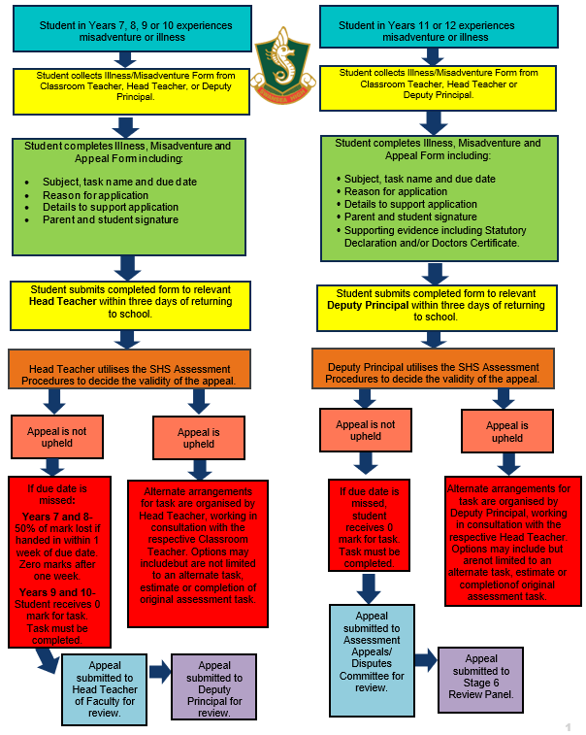
Illness/Misadventure/Appeals Procedures for Years 7-10
Procedures
If a student is absent on the day of a task being due, is requesting an extension or has circumstances which have impacted their preparation for a task, students in Years 7, 8 9 and 10 are required to submit an Illness/Misadventure/Appeal application, detailing reasons and signed by their parent or carer, to their classroom teacher or Head Teacher within three days of their return to school or within one week of the task due date if the student is absent. Forms can be obtained from the Deputy Principal, Head Teacher or downloaded from the SHS website.

Students should expect to complete the task/s on the day they return to school. If the classroom teacher deems this explanation to be valid, alternate task arrangements will be made such as:
- Student will complete the original assessment task or
- an extension of time for completion of the original task or
- completion of an alternate task or
- an estimate

If a student has missed more than one subject, they will submit their documentation to their relevant Deputy Principal. Documentation will be stored in the student’s file.

Submitting a parent letter or completing the Misadventure/Illness/Appeal application form does not guarantee approval and students must continue working on the task to the best of their circumstance and ability.

Communication Home
Non - submission of assessment tasks will result in a phone call or email home and a Faculty Letter of Concern letter on Sentral (Years 7 and 8) or N Warning Letter (Years 9 and 10) within one week of the task being due.

Late Submission of Tasks- Years 7 and 8
Where no Illness/ Misadventure/Appeal Form is submitted and approved, a penalty of 50% will be applied if the task is submitted within one week of the submission date. After one week, zero marks will be allocated to the task but feedback will be provided to support learning development. Task submission is still required after two weeks.

Late Submission of Tasks- Years 9 and 10
Where no Illness/ Misadventure/Appeal Form is submitted and approved and a student misses the due date, a zero mark is awarded. Task submission is still required and feedback will be provided to support learning development.

Illness/Misadventure/Appeals Procedures for Years 11 and 12

Procedures
If a student in Years 11 or 12 is absent on the day of a task being due, is requesting an extension or has circumstances which have impacted their preparation for a task, students are required to submit an Illness/Misadventure/Appeal application, signed by their parent or carer with accompanying supporting documentation (e.g. Doctors Certificate or Statutory Declaration signed by a JP) to their Deputy Principal on their first day back at school or within three days of the task due date or within one week if the student is absent. Misadventure/Illness/Appeals Forms can be obtained from the Deputy Principal, Head Teacher or downloaded from the SHS website.

If a student has been absent, they should expect to complete the task/s on the day they return to school. If the Deputy Principal deems this explanation to be valid, alternate task arrangements will be made via consultation with the Head Teacher of the faculty such as:
- Student will complete the original assessment task or
- an extension of time for completion of the original task or
- completion of an alternate task or
- an estimate
Documentation will be stored in the student’s file and a copy will be stored in the Stage 6 Monitoring Folder. The relevant Deputy Principal will add details on Sentral.

Late Submission of Tasks
Assessment Tasks submitted late will be awarded a zero mark unless a successful Illness/Misadventure/Appeal has been granted. If a task is not submitted, or a student’s application has been declined, students will still be required to complete the task in order to resolve an N-Warning, with feedback provided to assist in the learning cycle.

Communication Home
Non - submission of assessment tasks will result in a phone call or email home and a N-Warning letter on Sentral within one week of the task being due.

Appeals
Students may appeal, in writing, the outcome of an assessment task or the outcome of a Misadventure/Illness/Appeal Application. The appeal must clearly state the reason(s) for the appeal. Where relevant, the appeal must have attached any supporting documentation. Any appeal must be submitted within one week of receiving feedback about the task or notification of the outcome of the Misadventure/Illness/Appeal application. If the outcome is questioned by the student or parent, they can approach the Appeals Committee. This committee will be convened by the alternate Deputy Principal.
SHS deems the following situations as grounds for an appeal:
  - the task has not been weighted in line with the NESA requirements
  - the task has not complied with the stated assessment program and/or assessment requirements
  - there has been a miscalculation or a clerical error when deciding the assessment mark.

If the outcome is questioned by the student or parent, they can approach the Appeals Committee. This committee will be convened by the Principal.

Where possible, reviews will be resolved within the school. However, provision has been made for subsequent appeals to NESA. There is no appeal against the marks awarded for individual assessment tasks. NESA will consider only whether the review process was adequate and that the conduct of the review was proper in all respects. Since the appeal is directed to the assessment process, NESA itself will not revise the assessment marks or rank order. If the appeal is upheld, NESA will direct the school to conduct a further review (NESA 2015).

Students in Danger of Not Meeting Requirements

Monitoring Satisfactory Course Completion
Satisfactory completion can be judged by evidence regarding sustained application and diligence to learning experiences in class, home tasks and assessment tasks. Failure to meet one or more of these requirements may lead to an ‘N’ or ‘Non-Completion ’N’ determination. An ‘N’ determination for a course may make a student ineligible for the HSC.

SWANSEA HIGH SCHOOL
FACULTY WARNING FLOW CHART
YEARS 7-8

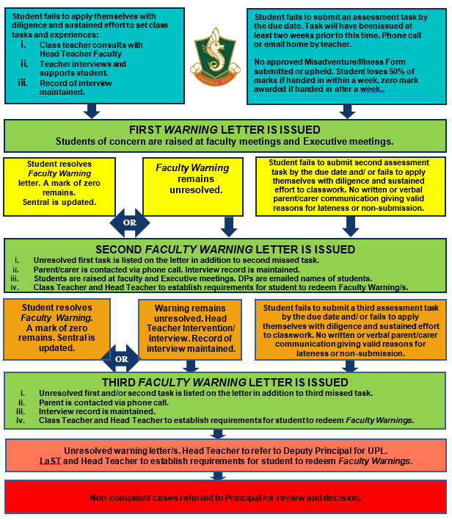

SWANSEA HIGH SCHOOL
N AWARD FLOW CHART
YEARS 9-12
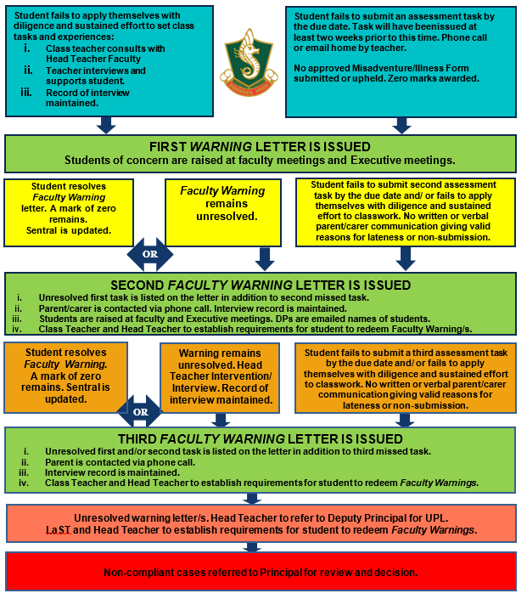

Disability Provisions

HSC and School Based Assessment Disability Provisions
For Year 12 students, SHS follows the 2020 NESA Disability Provisions and NSW Department of Education policy:

- ‘Disability provisions for the HSC Examination, in the form of practical arrangements, are implemented to assist a student to make a fair attempt to show what they know in an exam room. Regardless of the nature of the special need, the provisions granted will be solely determined by the implications of the student’s functioning in an examination situation. NESA determines disability provisions for the Higher School Certificate examinations (2019 NSW Department of Education).

- Disability provisions provide students with practical support to access, i.e. read and respond to, the Higher School Certificate (HSC) exams. In providing disability provisions for the HSC exams, NESA complies with the Disability Discrimination Act 1992 (Cth) (DDA) and the Disability Standards for Education 2005, issued under the DDA. Disability provisions are one way that NESA ensures there are reasonable adjustments available to students with disability so that they can access and participate in the HSC on the same basis as students without disability.

- Disability provisions address students’ exam needs related to learning, medical, vision or hearing disabilities. For example, students with a:
  - learning disability may use reader or writer
  - medical disability may access toilet breaks or use adapted furniture
  - vision disability may use braille or large-print papers
  - hearing disability may use an oral or sign interpreter.

- All schools must ensure that students with disability are able to access and participate in education on the same basis as other students. Schools should regularly assess their students’ learning needs and implement adjustments as required to support students on a day-to-day basis throughout their schooling.

- Adjustments provided in school may change over time in response to a student’s changing needs. Adjustments should be determined collaboratively with the student, parents/carers and other people who support the educational needs of the student. It may be considered discriminatory if adjustments are not in place for identified students with a disability. Schools are responsible for any decisions made at school level to offer adjustments to students with a disability in school-based tasks. School- determined adjustments will not necessarily apply in the Higher School Certificate examinations as what is assessed in school-based assessments may be different to HSC examinations.

- In addition, for HSC examinations, each HSC disability provisions guide for teachers and parents is assessed to ensure consistency and equity across the entire HSC cohort. NESA only approves disability provisions for the HSC exams.

- When providing students with adjustments for school-based assessments, schools are encouraged to take into account NESA’s key messages and principles for exam modifications to ensure that, where appropriate, adjustments are put in place that are consistent with disability provisions granted for the HSC.

- There is no guarantee NESA will grant the same provisions as those given at school. (2020 NESA)’
Years 7-11 Disability Provisions
SHS follows the guidelines provided by the NSW Department of Education for disability provisions:

- ‘The school learning and support team assists teachers to meet the educational needs of their students and to identify appropriate adjustments that may be needed. Parents and carers have a vital role to play in the work of the school learning and support team by taking part in discussions and planning.

- Adjustments made in consultation with a student's parents and carers are based on the personalised needs of the student.

- Consultations may also involve the principal, class and support teachers, professional therapists, and community service providers as well as family members and carers. Schools may also consult with specialist staff who can help to identify how adjustments can be made.

- Adjustments must be regularly reviewed through this consultation process and should be changed or withdrawn if necessary.

- Identification of a child with a disability or a learning difficulty can occur at any age or stage of the child's development.

- If adjustments are made for teaching and learning, then similar adjustments should be made for assessment tasks. This allows students to demonstrate what they know and what they can do in relation to curriculum outcomes. Adjustments to assessment tasks can be applied to:

    - assessment processes, e.g. scaffolds, additional, time, use of a reader and or writer, rest breaks
    - assessment tasks, e.g. rephrasing questions, using simplified language
    - the content being assessed, e.g. fewer or alternative syllabus outcomes
    - the format of a task, e.g. written point form instead of reports or essays, oral or PowerPoint presentation instead of essay’ (NSW Department of Education 2020).

At the discretion of SHS Senior Executive and Head Teacher Faculty, the delivery or mode of the assessment may be adjusted without changing the way in which the assessment is marked.

Malpractice

All work presented in assessment tasks and external examinations (including submitted works and practical examinations) must be a student’s own or must be acknowledged appropriately. Malpractice, including plagiarism, could lead to students receiving zero marks and will jeopardise a student’s results.

Malpractice is any activity that allows students to gain an unfair advantage over other students. It includes, but is not limited to:

- copying someone else’s work in part or in whole, and presenting it as their own
- using material directly from books, journals, CDs or the internet without reference to the source
- building on the ideas of another person without reference to the source
- buying, stealing or borrowing another person’s work and presenting it as their own
- submitting work to which another person, such as a parent, coach or subject expert, has contributed substantially
- using words, ideas, designs or the workmanship of others in practical and performance tasks without appropriate acknowledgement
- paying someone to write or prepare material
- breaching school examination rules
- using non-approved aids during an assessment task
- contriving false explanations to explain work not handed in by the due date
- assisting another student to engage in malpractice
- submitting a task that was generated through AI or Generate Large Language Model technology.

In the case of suspected plagiarism, students will be required to provide evidence that all unacknowledged work is entirely their own. Such evidence might include but is not limited to the student:

- providing evidence of and explaining the process of their work, which might include diaries, journals or notes, working plans or sketches, and progressive drafts to show the development of their ideas
- answering questions regarding the assessment task, examination or submitted work under investigation, to demonstrate their knowledge, understanding and skills.

The completion of the NESA program HSC: All My Own Work is mandatory for students who are entered in Preliminary courses. It is designed to help students follow the principles and practices of good scholarship. This includes understanding, valuing and using ethical practices when locating and using information as part of their stage 6 studies. Students who have completed the program will also know about penalties for cheating and how to avoid malpractice when preparing their work for assessment’ (NESA 2019).

Procedures for Malpractice in Tasks
Students found to have engaged in malpractice will be awarded a zero mark and be required to complete the task again or complete an alternate task at the discretion of the Head Teacher Faculty and Senior Executive.

Malpractice is taken seriously at Swansea High School and may result in:
- zero marks for part or all of the assessment task/examination
- potential further disciplinary action taken by the school (e.g. detention, suspension, etc.) and
- documenting the malpractice on the NESA Malpractice Register.

Procedures for Malpractice in Examinations
Students found to breach any examination requirements may be removed from the examination and awarded a mark of zero. Students removed from an examination room will report to a Head Teacher Faculty.

All students are expected to behave in alignment with the Exam Conditions as detailed earlier in this document.

Appeals against Malpractice Penalties
In the case of some assessment tasks (such as research tasks, major works, or projects) a log of student work is required and must be presented on request. Drafts, proofs, and rough copies of assignments should be kept to support the authenticity of the submission.

The student must appeal this decision within three school days of written notification of the zero penalty being given. Appeals must be made in writing to the relevant Deputy Principal who will submit the form to the Assessment Appeals Committee.

Marking and Feedback

At SHS, student achievement in relation to syllabus outcomes and standards, is determined through the collection of evidence in the form of formal assessment tasks and is used for grading and ranking students within each of the courses. NESA promotes a standards-referenced approach to assessment and reporting and each syllabus states what students at each learning stage are expected to learn.

Grading student achievement is the process of assigning a letter (A, B, C, D, E) to summarise the level of a student’s achievement in a course. In Mathematics, grades have been further differentiated to nine levels for the RoSA only (A10, A9, B8, B7, C6, C5, D4, D3, E2).

Awarding Marks for an Assessment Task
Marks must be awarded against explicit marking guidelines which should be developed against the course descriptors for individual subjects.

Marking guidelines on this template need to be detailed, explicit and show clearly where marks are allocated. This information is to be provided for students with the understanding that students can essentially use the assessment criteria to grade their own work to gauge assessment task progress and self-assess.

The teacher must assess the student’s actual performance, not potential performance. Assessment marks must not be modified to take into account possible effects of illness or domestic situations unless an Illness/Misadventure/Appeal Form has been submitted and upheld. Attendance and application are not to be taken into account in the final assessment mark or in any individual assessment task.

Marks must also accurately correlate and reflect the outcomes that are being assessed. Marks must be distributed throughout tasks in an equitable manner commensurate with task complexity, but tasks should be weighted more heavily toward the end of the course completion.

NESA requires all students to follow an assessment program and have an assessment mark submitted. The minimum requirement is that the student must make a genuine attempt at assessment tasks that contribute in excess of 50 percent of available marks in the course. A student who does not comply with the assessment requirements and receives an ‘N’ determination in a course will have neither an assessment mark nor an examination mark awarded for that course.

Assessment Feedback for Individuals and Classes
All feedback and marks should be returned to students within two weeks of the task submission. All students are required to acknowledge receiving feedback by signing the SHS Stage 4, 5 and 6 Assessment Task Receipt Register.

Stage 6 Rank Order Advice
An assessment task rank is to be provided for each Stage 6 assessment task. Cumulative assessment rank should be provided throughout the year or as a result of student request. Cumulative Rank Order is to be provided on official report documents. A cumulative rank is to be provided after each assessment task.

Satisfactory Completion of the Course
A student will be considered to have satisfactorily completed a course if there is sufficient evidence that the student has:

i. followed the course developed by NESA or endorsed by NESA and
ii. applied themselves with diligence and sustained effort to the set tasks and experiences provided in the course by the school and
iii. achieved some or all of the course outcomes.

Satisfactory completion of the Preliminary course is a prerequisite for entry into a HSC course. In cases of non- completion of course requirements (both Preliminary and HSC), an ‘N’ determination (non-award) may be made.

The Principal may determine that a student has not applied themselves with diligence and sustained effort to the set task and experiences provided by the course in the school. The Principal may recommend to NESA that a student will receive an ‘N’ determination for the course.

Establishing Student Performance Years 7-10
For Years 7-10, teachers use NESA Common Grade Scale to make professional on-balance judgments to determine which performance descriptor best matches the standards their students have achieved. Additional evidence such as formative assessment, class work and observations can be used to support any variation from the formal grade/mark. Adjusting of marks for final grades is to be done in consultation with staff, led by the Head Teacher Faculty, and approved by the Senior Executive. Marks do not necessarily represent the achievement level of a student as outlined in performance descriptors.

The grade awarded to each student at the completion of a Stage 5 course should indicate the student’s overall achievement in relation to the Course Performance Descriptors (for Board Developed Courses) or the Common Grade Scale (for School Developed Board Endorsed Courses and Content Endorsed Courses). These grades should be reflected in the marking of assessment tasks.

Students undertaking a course based on Life Skills outcomes and content are not allocated a grade in that course. Students undertaking a Stage 5 VET course are not allocated a grade in that course.

Establishing Student Performance Year 11
For Year 11, SHS follows NESA guidelines:

‘These grades are determined by the student’s performance in relation to the Common Grade Scale for Preliminary Courses or the Course Performance Descriptors. Teachers make professional, on- balance judgements about which grade description best matches the standards their students have demonstrated by the end of the course.

Teachers are required to ensure that the grades awarded are consistent with published standards. This means that the grade a student receives in one school can be compared to the same grade anywhere in NSW. To ensure judgements are consistent with statewide standards, teachers compare their students’ work with work samples on NESA website that are aligned to the A to E Common Grade Scale for Preliminary Courses. The grade awarded is reported on a student’s Record of School Achievement (RoSA), a cumulative credential that allows students to accumulate their academic results until they leave school. It is also reported on their HSC credential’ (NESA 2019).

Establishing Student Performance Year 12
The Year 12 assessment marks submitted to NESA must establish the rank order and reflect the relative difference between students’ performances for the course.

‘Schools are responsible for providing information to NESA about student performance in school-based assessments. The type of information that is provided to NESA depends on the course. The Assessment and Reporting documents located on the syllabus page for each course detail the requirements.

HSC Grades
Schools will use Achievement Level Descriptions to award grades (A to E) to all students who complete Year 12 courses in English Studies and Mathematics Standard 1. The grades awarded to students for school-based assessment in these courses will be reported on the HSC credential.

Students who leave school prior to the Higher School Certificate examinations will receive a RoSA. It records grades for their completed Stage 5 and Year 11 courses and any participation in Stage 6 courses that were not completed.

Providing adjustments to assessment tasks for a student with disability does not restrict the student’s access to the full range of grades.

HSC Final Assessment Marks
‘Schools will submit a final assessment mark for each Board Developed course a student completes (other than Life Skills, VET and English Studies and Mathematics Standard 1 courses). At the conclusion of the assessment program, schools will add up the assessment marks for each task ensuring that the components and weightings detailed in the Assessment and Reporting documents have been applied.

‘Schools can advise students of their rank order in each course, but must not inform students of their final, cumulative, school-based assessment mark as these marks will be moderated based on examination performance and aligned to the performance standards. Students can access their Assessment Rank Order Notice in Students Online after the last HSC examination. If a student thinks that the rank order is not correct, they can seek advice from the school about the rank order appeal process.’

Ensuring Security of Major Works
Assessment tasks in the form of practical major works (structures, artworks, furniture etc.) are to be placed in a secure environment when the student is not working on that major work. A secure environment is one that prevents ready access to the major work by other students and prevents, as best possible, the event of breakage or destruction. The security of major works during transportation to and from school is the responsibility of the student.

Accumulation of Preliminary Courses
There is no time restriction on the accumulation of Preliminary courses. Students may accumulate HSC courses towards the Higher School Certificate up to five years. The five-year period will commence in the first year the student satisfactorily completes an HSC course. Accumulation of HSC courses cannot extend over more than a five-year period. The five-year period is a ‘rolling period’ so that students wishing to go beyond the five years will have the earliest year’s presentation deleted.

Invalid Tasks
Invalid tasks are tasks that do not directly assess the outcomes intending to be assessed. Invalid tasks may also offer advantage to some students while providing a disadvantage to others. Assessment should also provide all students the opportunity to achieve at a range of levels. Tasks which do not provide scope for this and are, therefore, non-discriminating, are considered invalid. The Senior Executive, in consultation with the Head Teacher Faculty, will determine the resulting course of action and notify all impacted students and their parents/carers.

Grade Appeals to NESA
Students wishing to appeal against the grade(s) in any subject awarded to them by the school must submit a written appeal, together with evidence, to their principal. If the appeal is upheld, the principal will send notification of the new grade(s) to NESA. In order to be successful in such appeals, students will need to substantiate that the grade(s) awarded in the course(s) was inconsistent with the progressive reporting from the school.

Since the appeal is directed to the progressive reporting by the school, NESA will not revise individual tasks or test marks. Appeals management will reflect processes set out in the ACE manual regarding Student Appeals Against Assessment Rankings in HSC Courses:

‘Where possible, all reviews will be resolved within the school. However, provision has been made for subsequent appeals to NESA. There is no provision for appeal against the marks awarded for individual assessment tasks.

NESA will consider only whether:
- the school review process was adequate for determining whether:
- the weightings specified by the school in its assessment program conform with NESA requirements as detailed in the syllabus packages
- the procedures used by the school for determining the final assessment mark conform with its stated assessment program – in particular, the weightings used for the various assessment tasks should be consistent with those specified in the assessment program
- there are no computational or other clerical errors in the determination of the assessment mark.
- the conduct of the review was proper in all respects.

Since the appeal is directed to the assessment process, NESA will not itself revise assessment marks or the order of merit.

If the appeal is upheld, NESA will refer the matter back to the school for a further review. The results of that review may affect the assessment of the student making the appeal and/or the assessments of other students. This may then be reflected in the moderated assessment marks for all students so affected.

NESA will not consider further appeals from other students whose assessments or ranking may be affected by reviews or appeals. The reason is that, although initiated by individual students, the reviews and appeals relate to the assessment process and are designed to correct any errors affecting the assessments for the entire school required.

